Unit 8 – Worksheet 5 – Solutions & Solubility

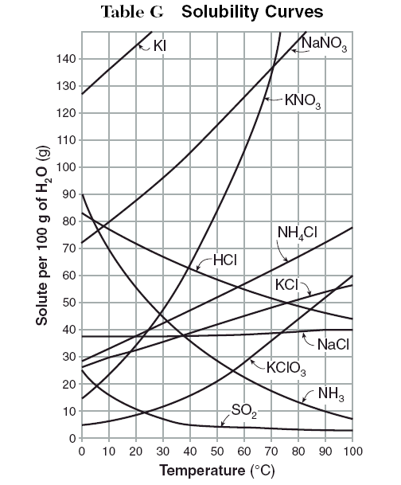
Use the graph to the left to answer questions 1-9.
- How many grams of the following substances will dissolve at the given temperature?
  - KNO₃ at 70˚C = _______ g. NH₃ at 20˚C = _______
  - NH₄Cl at 90˚C = _______ h. KClO₃ at 75˚C = ______
  - NaCl at 100˚C = _______ i. KCl at 75˚C = _______
  - KI at 20˚C = _______ j. HCl at 10˚C = _______
  - NaNO₃ at 35˚C = _______ k. KNO₃ at 10˚C = ______
  - SO₂ at 50˚C = _______ l. NH₄Cl at 65˚C = ______
- _____ According to Table G, which solution is saturated at 30˚C?
  - 12 g of KClO₃ in 100 g of H₂O
  - 12 g of KClO₃ in 200 g of H₂O
  - 30 g of NaCl in 100 g of H₂O
  - 30 g of NaCl in 200 g of H₂O
- _____ 100 g of H₂O is saturated with NH₄Cl at 50˚C. According to Table G, if the temperature is lowered to 10˚C how much NH₄Cl will precipitate?
  - 5 g b. 17 g c. 30 g d. 50 g
- Which solute is least affected by temperature?

- Which solute is most affected by temperature?

- Which solute(s) have solubilities that decrease as temperature increases?

- At 23˚C, 60 g of NaNO₃ is dissolved in 100 g of H₂O. How many more grams of NaNO₃ must be added to make the solution saturated?

- At what temperature will NH₄Cl and HCl have the same solubility?

- At what temperature will 29 g of NH₃ dissolve in 100 g of H₂O to make a saturated solution?

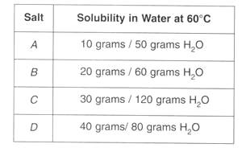
Use the data table to answer question 10.
- Which salt is most soluble at 60˚C?

- A student uses 200 g of water at 60˚C to prepare a saturated solution of KCl.

  - Identify the solute in this solution.

  - According to Table G, how many grams of KCl must be used to create this solution?

  - This solution is cooled to 10˚C and the excess KCl settles out. If the resulting solution is saturated, how many grams settled out? (Use Table G)
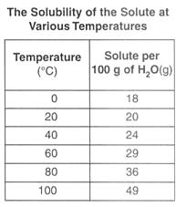
Base your answers to questions 12-13 on the table to the left.
- Graph the data from the table on the grid below. Be sure to label your graph axes and give it a title.
- Based on the data table, if 15 g of solute is dissolved in 100 g of H₂O at 40˚C, how many more grams can be dissolved to make a saturated solution at 40˚C?

- According to Table G, which substance forms an unsaturated solution when 80 g of the substance dissolves in 100 g of water at 10˚C?

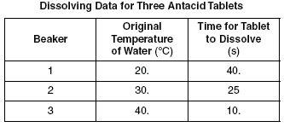
A student conducts an experiment to determine how the temperature of water affects the rate of dissolving for antacid tablets. Use their collected data to the left to answer questions 16-18.
- Describe the effect of temperature on the rate of dissolving.

- Explain, in terms of the kinetic molecular theory, how temperature influences the rate of dissolving.

- What changes, other than temperature, would affect the rate of dissolving?

- _____ According to Table G, a temperature change from 60˚C to 90˚C has the least effect on the solubility of which substance?
  - SO₂ b. NH₃ c. KCl d. KClO₃

