Model 10 – Current Electricity
Worksheet 3 – Combination Circuits
(You must draw each circuit in your lab notebook and show all work!)

1. A 110-V household circuit that contains an 1800-W microwave, a 1000-W toaster, and an 800-W coffeemaker is connected to a 20-A fuse. Determine the current. Will the fuse melt if the microwave and the coffeemaker are both on? (Hint: How do you think appliances are connected in your home?)

2. Determine the equivalent resistance of the circuit, the current in the circuit, and the current across the 2 ohm resistor.
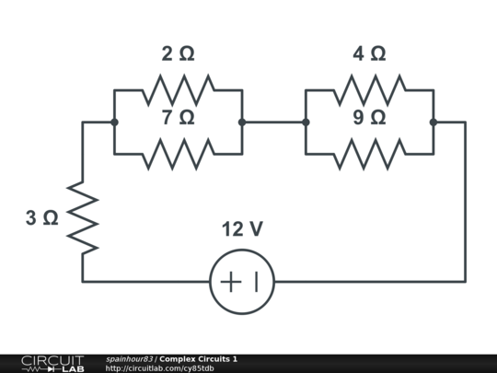
3. Determine the equivalent resistance of the circuit, the current in the circuit, the current across the 6 ohm resistor, and the current across the 4 ohm resistor.
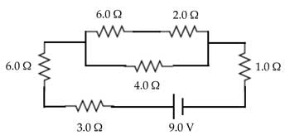

4. Resistors R₁, R₂, and R₃ have resistances of 15.0 Ω, 9.0 Ω, and 8.0 Ω  respectively. R₁ and R₂ are connected in series, and their combination is in parallel with R₃ to form a load across a 6.0-V battery.
a. What is the total resistance of the load?
b. What is the current in R₃?
c. What is the potential difference across R₂?

5. A 15.0-Ω  resistor is connected in series to a 120-V generator and two 10.0-Ω resistors that are connected in parallel to each other.
a. What is the total resistance of the load?
b. What is the magnitude of the circuit current?
c. What is the current in one of the 10.0-Ω resistors?
d. What is the potential difference across the 15.0-Ω  resistor?

